Revision History

Version | Date | Author | Change Summary
0.1 | 05/14/2009 | B.Bentley | DRAFT

Table of Contents

1. Definitions 5
2. Subscription/Payment Process Overview 7
3. Subscription Rules - Subscriptions will be governed by the following high-level rules. 8
3.1 System Elements and Hierarchy 8
3.2 Monthly Recurring Billing 9
3.3 Annual Recurring Billing 9
3.4 Promotional Codes 11
4. Tax Calculations and Distribution 11
4.1 Tax Rate Updates 11
4.2 Tax Payments Calculations 11
4.3 Tax Remittance 11
5. CC Data Collected 11
5.1 Credit Card Information 12
5.2 Billing Address 12
6. Editing Billing Profile 12
7. Data Transmission 12
8. Data Storage 12
8.1 Stored Elements 13
9. Tools for Manual credit/debit memo handling 13
10. Billing Related Notifications 13
10.1 Subscription Created / Initial Charge Success 13
10.2 Recurring Charge Success (monthly subscription) 13
10.3 Recurring Charge in 30 days (annual subscription) 13
10.4 Expiration Date Approaching/Past 13
10.5 Recurring Charge Denied 14
10.6 Billing Profile Changed 14
11. Subscription Process/UI 15
11.1 Select a Subscription 15
15
11.2 Selection Confirmation 15
Figure 11.2 – Confirm You Selection Screen 15
15
11.3 Enter your Billing Information 16
11.4 Confirm Billing Information 16
11.5 Payment Confirmation 17
17
12. Example Billing Scenarios 17

- Definitions
- Subscription
Container element that combines all Billing Elements into a single element to facilitate charging the customer. Subscriptions can be Monthly or Yearly.
- Account
Highest level element in the system hierarchy.
- Subscription Amount
The amount charged to the customer for MOBD service.
- Monthly Recurring Billing
Monthly Automatic billing of a customer credit card
- Annually Recurring Billing
Annual automatic billing of a customer credit card.
- Monthly Subscription Amount
The amount charged per Month to the customer for each House containing a Billing Element. ($x)
- Yearly Subscription Amount
The amount equal to the Monthly Subscription Amount multiplied by 12.
- Annual Subscription Amount
Is a calculation of the Yearly Subscription Amount less the Annual Subscription Discount
- Annual Subscription Discount
Is a calculated discount based on a percentage of time between the Last Billing Date and the Next Billing Date
- Billing Event
Any customer action that causes a charge to the customer’s credit card.
- Subscription Creation Date
The date the Subscription was created in the customer’s Account
- Last Billing Date
Is the date (Monthly or Yearly) that the last charge was made on the customer’s credit card.
- Next Billing Date
Is the date (Monthly or Yearly) that the next charge attempt will be made on the customer’s credit card.
- Current Billing Period
The period of time between the Last Billing Date and the Next Billing Date.
- PFP
Pay Flow Pro – PayPal payment services vendor
- Billing Elements
A device that requires a subscription on an Account for access. A Bridge or a Camera.
- House
Container element that can have one or many Billing Elements
- Bridge
Billing Element related to MOBD home automation
- Camera
Billing Element related to MOBD video solution
- Theoretical Monthly Billing Date
The day of each calendar month related to the creation date of a Yearly Subscription
- Recurring Billing Profile Calculation
The nightly batch calculation that determines the Subscription Amount for each customer based on their Subscription and the Houses on their Account with active Billing Elements.
- Minimum Charge Amount
The minimum charge that we will attempt to charge a customer’s credit card.
- End of the Month Billing Date
Any billing date falling on the 29th, 30th or 31st of the month.
- Billing Address
The address related to the customer’s credit card.
- Location Address
The address related to the House.

- Subscription/Payment Process Overview
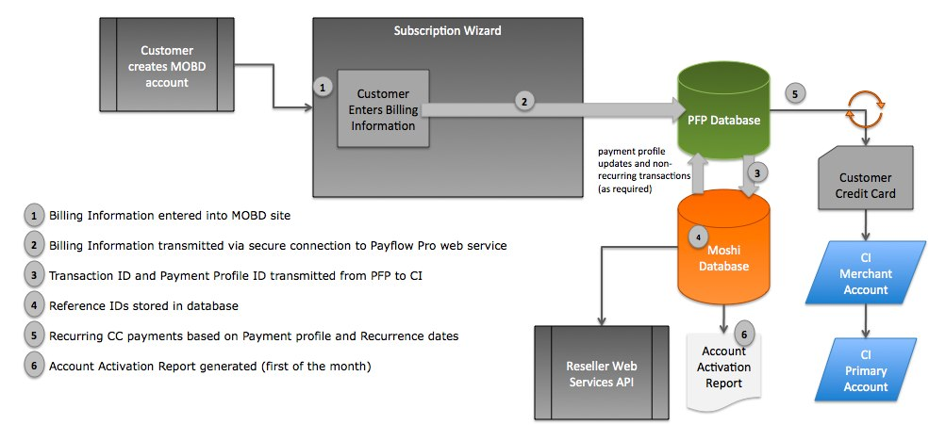

- Subscription Rules - Subscriptions will be governed by the following high-level rules.
  - System Elements and Hierarchy
Subscriptions will be coupled at the Account level. All Billing Elements in an Account will result in a single Subscription Amount that will be calculated based on those elements. Any Billing Element that is added or removed from an Account will result in a change in the Subscription Amount and may result in one or many of the following events:
- One-time charge to customer’s credit card
- One-time refund to customer’s credit card
- Change in customer’s Recurring Billing Profile Calculation

Figure 2.1 – System Elements and Hierarchy

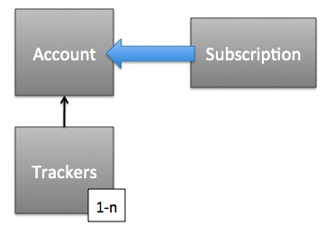

  - Monthly Recurring Billing
Monthly Recurring Billing will result in a monthly Billing Event based on the Recurring Payment Profile Calculation that will bill the customer each month in advance for MOBD service.

    - Subscription Cost

The Monthly Subscription Amount will be first collected (plus tax, See 3.4) on the Subscription Creation Date.
    - Recurring Payments

The Monthly Subscription Amount will be collected every month on the same day of the month. The Next Payment Date will not be adjusted to a different date except for subscriptions created at the end of the month.
      - End of the Month Billing Dates
Monthly accounts created on the 29th, 30th, or 31st will be billed on the last day of the month if that month is too short to bill on the regular billing day. The "new" billing day will NOT be permanent.

    - Removal of a Tracker
      - Removal of the only Tracker on an account will result in an immediate cancellation of the Subscription.

No refund of the subscription amount will be given.

All Billing Elements will be removed from the User Account and the Account will be reset back to the Setup Wizard Mode.
      - Removal of one of many Trackers on an account will result in cancellation of the user’s access to the subject Tracker(s) on the next Billing Date.

No refund of the Subscription amount will be given.

All Billing Elements related to the subject Tracker will be removed from the User Account and the recurring Subscription amount will be updated to reflect the changes.
    - Cancelling an Account

The User will have the option to Cancel an Account at the Account level.

No refund of the subscription amount will be given.

All Trackers and Billing Elements will be removed from the User Account and the Account will be reset back to the Setup Wizard Mode.

The Subscription will automatically be terminated immediately.

    - Addition of a Tracker
Adding a Tracker will result in a prorated charge based on the number of days remaining in the Current Billing Period. This prorated charge will be charged immediately to the customer’s card if it is greater than the Minimum Charge Amount. If the charge is less than the Minimum Charge Amount, it will be added to the following month’s recurring charge. This proration will result in a single monthly billing day per account. All subscription charges will be combined and billed as a single charge to the customer. This prorated calculation will be based on the following:

Charge Amount = M - (n/30*M), where M is the Monthly Subscription Amount and n is the number of days from the last billing date to the current date.

  - Annual Recurring Billing
Annual Recurring Billing will result in an annual Billing Event based on the Recurring Payment Profile Calculation that will bill the customer each year in advance for MOBD service.

    - Subscription Cost
The Annual Subscription Amount will be collected (plus tax, See 3.4) on the Subscription Creation Date.
The Annual Subscription Amount will be calculated based on the following equation:

A = Y – D, where A is the Annual Subscription Amount, Y is the Yearly Subscription Amount and D is the Annual Subscription Discount.
      - Recurring Payments
The Annual Subscription Amount will be collected every year on the anniversary of the Subscription Creation Date. The payment date will not be adjusted to a different date except for Subscriptions created on February 29th of a Leap Year.

        - Leap Year Subscriptions
Annual accounts created on Feb. 29th will be billed on the last day of February if it is a non-leap year. The "new" billing day will NOT be permanent.

    - Removal of a Tracker
      - Removal of the only Tracker on an account will result in an immediate cancellation of the Subscription.

The User will be eligible for a partial refund of the Subscription amount. This refund will be based on a calculation as follows:

Refund = A - (n*M), where A is the Annual Subscription Amount, n is the number of Theoretical Months the subscription was active and M is the Monthly Subscription Amount.

If the result of this calculation is less than the Minimum Charge Amount, then no refund will be issued to the customer.

The Subscription will be cancelled and the Tracker and related Billing Elements will be removed from the User Account and the Account will be reset back to the Setup Wizard Mode.
      - Removal of one of many Trackers on an account will result in removal of the User’s access to the subject Tracker(s).

The User will be eligible for a partial refund of the Subscription amount. This refund will be based on a calculation as follows:

Refund = A - (n*M), where A is the Annual Subscription Amount, n is the number of Theoretical Months the subscription was active and M is the Monthly Subscription Amount.

If the result of this calculation is less than the Minimum Charge Amount then no refund will be issued to the customer.

All Billing Elements related to the subject Tracker will be removed from the User Account and the recurring subscription amount will be updated to reflect the changes.

The Tracker and all related Billing Elements will automatically be removed from the Account on the next Theoretical Monthly Billing Date.
    - Addition of a Tracker
Adding a Tracker will result in a prorated charge based on the number of days remaining in the Current Billing Period factoring in an Annual Subscription Discount. This prorated charge will be charged immediately to the customer’s card if it is greater than the Minimum Charge Amount. If the charge is less than the Minimum Charge Amount, it will be added to the amount of the Next Billing Date. This proration will result in a single annual billing date per account. All Subscription charges will be combined and billed as a single charge to the customer. This prorated amount will be partially discounted based on the Annual Subscription Discount and the remaining time in the Current Billing Period. The Annual Subscription Discount will be adjusted to reflect the portion of the total time remaining before the Next Billing Date. This prorated calculation will be based on the following:

Charge Amount = Y - (n/365 * Y) - (N/365 * N/365 * D) where n is the number of days since the Last Billing Date, N is the number of days until the Next Billing Date, Y is the Yearly Subscription Amount, D is the Annual Subscription Discount

    - Account Cancellation

The User will be eligible for a partial refund of the Subscription amount. This refund will be based on a calculation as follows:

Refund = A - (n*M), where A is the Annual Subscription Amount, n is the number of Theoretical Months the subscription was active and M is the Monthly Subscription Amount.

If the result of this calculation is less than the Minimum Charge Amount, then no refund will be issued to the customer.

All Billing Elements related to the subject Tracker will be removed from the User Account and the Recurring Billing Profile Calculation will be updated to reflect the changes.

The Subscription will automatically be terminated on the next Theoretical Monthly Billing Date. The Account will be reset back to the Setup Wizard Mode.

  - Promotional Codes
Promotional Codes will allow certain users to receive discounted or free service based on entering a code into the billing system and selecting a subscription plan that is associated with that code. Promotional Codes can apply to either the monthly payment option, the annual payment option, or both.
    - A properly formatted and validated Promotional Code will result in adjusted subscription options for the customer to choose from.
    - An invalid Promotional Code will result in standard subscription options for the customer to choose from (ie. No error messaging will be applied to validating Promotional Codes)
- Tax Calculations and Distribution
  - Tax Rate Updates
Tax rate update services are provided by a monthly update service called Tax Data Systems (www.taxdatasystems.com). These update files contain all US Sales Tax rates by municipality and are manually uploaded on a monthly basis to update Tax calculations.

  - Tax Payments Calculations
Tax Payments are calculated by utilizing the customer’s 5-digit Billing Zip Code that is associated with their subscription.
Taxes are calculated based on Billing Address, not Location Address.
Taxes are calculated and charged for every Billing Event.

  - Tax Remittance
Tax payments are collected by Crayon Interface and distributed to each State (as applicable) every month based on the total amount of Sales tax collected in the prior month.

- CC Data Collected
The following billing related data will be collected from the customer at the time the Subscription is created.
  - Credit Card Information
    - Type of Card (required)

Alphabetical list containing; American Express, Discover, MasterCard, Visa [defaults to blank]

    - Name (As it appears on card) (required)

Max 32 character varchar
    - Credit Card Number (required)

Max 16 digit numeric (spaces and dashes not accepted)
    - Expiration Date (required)
      - Month
Drop-down list of two-digit months. [defaults to the current month with ‘hot-key’ access to next element in the list]

      - Year
Drop-down list of four-digit year. [defaults to the current year and displays the next 10 subsequent years]

    - CCV (required)

Max 4 digit numeric
      - Image depicting where CCV can be found on credit card will be included. This image will be dynamic based on Type of Card selection.
  - Billing Address
    - Country (required)
Alphabetical drop-down list of all countries (US as top selection). [defaults to US]
    - Address 1 (required)

Max 64 character varchar
    - Address 2 (optional)

Max 64 character varchar

    - City (required)

Max 32 character varchar
    - State / Province (required if country is US or Canada)
Alphabetical drop-down list of States/Provinces [defaults to blank]

    - Postal Code (required if country is US or Canada)
Field validation based on US and Canada only
Max 6 character varchar

- Editing Billing Profile
A customer may edit their billing profile information at any time in Account Settings. Only the Stored Elements (See 8.1) will be pre-populated on the page, the user will be required to re-enter all of the other information in Section 5.

- Data Transmission
All billing related data will be transmitted over a secure web connection in accordance with the PCI DSS standard.

- Data Storage
No billing related user-identifying information will be stored in the Crayon Interface database.

  - Stored Elements
Stored elements will be retrieved and displayed to the user on the Account Settings page to facilitate editing billing profile information.

    - Customer Name
    - Address 1
    - Address 2
    - City
    - State
    - Postal Code
    - Country
    - Type of Card
    - Expiration Date
    - Last 4-digits of Credit Card Number
    - Billing Postal Code
- Tools for Manual credit/debit memo handling
- Billing Related Notifications
  - Subscription Created / Initial Charge Success
“Congratulations! Your MOBD® subscription for account [login name] has been successfully created. Your first monthly(or annual) payment of $x has been charged to your [Type of Card] ending in [last 4 digits of card number]. You can review/update your credit card information at any time from the Account Settings tab in your online account. Thank you for your purchase!”
[billing statement info]
  - Recurring Charge Success (monthly subscription)
“This notice confirms that your recurring monthly subscription charge of $x has been charged to your [Type of Card] ending in [last 4 digits of card number] for your MOBD® account [login name]. You can review past payments or review/update your credit card information at any time from the Account Settings tab in your online account. Thank you for your purchase!”
[billing statement info]
  - Recurring Charge in 30 days (annual subscription)
“This email is to notify you that your recurring annual subscription charge of $x will be charged to your [Type of Card] ending in [last 4 digits of card number] for your MOBD® account [login name] on [Next Billing Date]. You can review/update your credit card information at any time from the Account Settings tab in your online account. Thank you for being a MOBD customer!”
[billing statement info]
  - Expiration Date Approaching/Past
“This email is to notify you that the expiration date of your [Type of Card] ending in [last 4 digits of card number] for your MOBD® account [login name] is about to expire. You will need to update your credit card information to ensure proper payment on your subscription for uninterrupted use of your MOBD system. You can review/update your credit card information at any time from the Account Settings tab in your online account. Click this link to access your account and update your information. Thank you for being a MOBD customer!”
  - Recurring Charge Denied
“This email is to notify you that your MOBD® account [login name] subscription payment was not processed successfully. An attempted charge for your recurring monthly payment of $x on your [Type of Card] ending in [last 4 digits of card number] did not go through. You will need to update your credit card information to ensure proper payment on your subscription for uninterrupted use of your MOBD system. You can review/update your credit card information at any time from the Account Settings tab in your online account. Click this link to access your account and update your information. Thank you for being a MOBD customer!”
  - Billing Profile Changed
“This email is to notify you that your credit card information for your MOBD® account [login name] has been changed via your online account. You can review/update your credit card information at any time from the Account Settings tab in your online account. If you believe this change to your account was made in error or is fraudulent, please contact customer care at 1-800-MOBD. Thank you for being a MOBD customer!”

- Subscription Process/UI
  - Select a Subscription
Figure 11.1 – Select a Subscription Screen

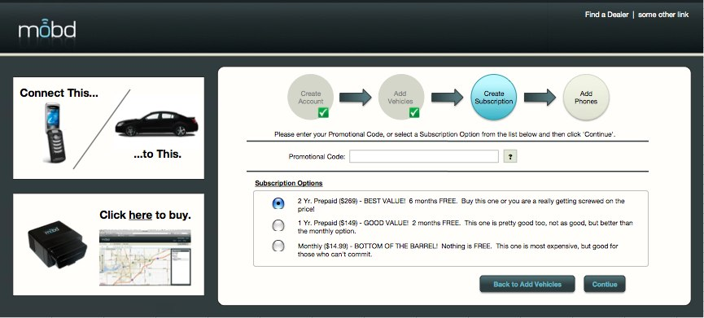

  - Selection Confirmation

Figure 11.2 – Confirm You Selection Screen

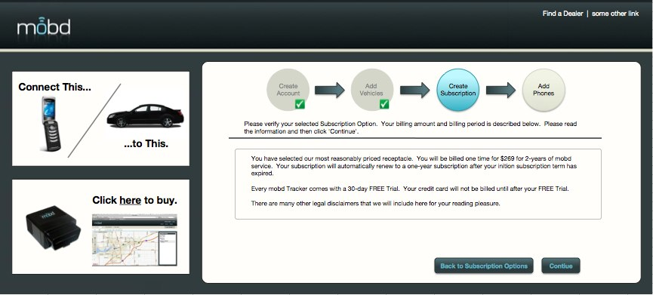

  - Enter your Billing Information
Figure 11.3 – Enter your Billing Information Screen

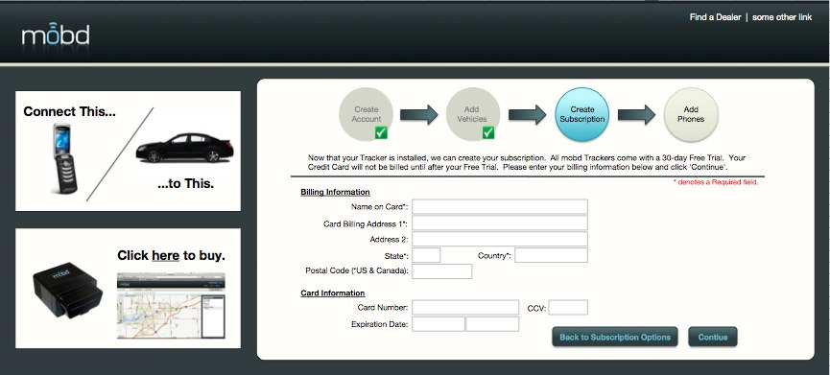

  - Confirm Billing Information
Figure 11.4 – Confirm Billing Information Screen

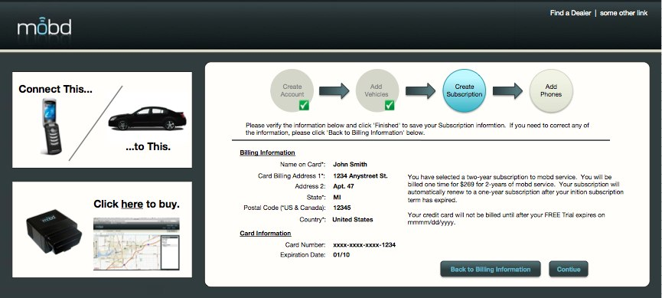

  - Payment Confirmation
Figure 11.5 – Payment Confirmation Screen

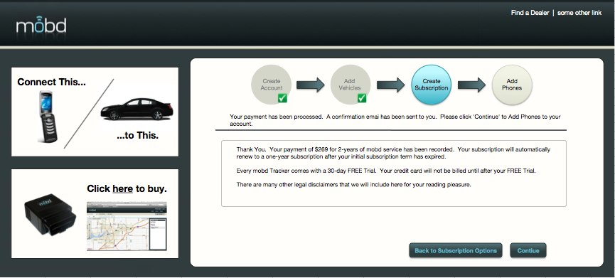

- Example Billing Scenarios
For the purpose of these examples, assume that the Monthly Subscription Amount is $15.00, the Annual Discount is $60.00, and that the Minimum Charge Amount is $1.00.

Scenario #1: Monthly Billing

John lives in a state with 6% sales tax. John signs up for MOBD service on January 31st, 2009, and chooses to pay monthly. His card will immediately be charged $15.00 + $0.90 tax, or $15.90.

On February 28th, his card is charged $15.90.
On March 31st, his card is charged $15.90.
On April 30th, his card is charged $15.90.

On May 15th, he logs into the portal to cancel his subscription. He will not receive any refund, and he will be able to use all of his MOBD features until May 31st. On May 31st, he will no longer be able to use any MOBD features unless he logs in and reactivates his subscription.

Scenario #2: Annual Billing

John lives in a state with 6% sales tax. John signs up for MOBD service on January 31st, 2009, and chooses to pay annually. His card will immediately be charged $120.00 + $7.20, or $127.20. This would be shown on his bill as follows:

- 12 Months MOBD Subscription @$15.00 $180.00
- Annual Discount $60.00

- Subtotal $120.00
- Taxes $7.20
- Total $127.20

John uses the product until May 15th, when he logs into the portal to cancel his subscription. John will receive a refund on his card that reflects the unused amount of his payment, NOT counting the discount.

In this case, John will see the following statement:

- Payment provided $120.00
- 4 Months subscription used (Jan 31st-May 31st) -$60.00

- Refund subtotal $60.00
- Taxes $3.60
- Refund total $63.60

John's card will be refunded a total of $63.60. He will be able to use all of his MOBD features until May 31st. Again, on May 31st he will no longer be able to use any MOBD features unless he logs in and reactivates his subscription.

Scenario #3: Annual Billing with no refund

John again has 6% sales tax and signs up for MOBD service on January 31st, 2009, and chooses to pay annually. His card will be charged $127.20.

This time, John uses the product until October 5th, when he decides to log into the portal and cancel his subscription. In this case John will no refund. A statement (if we generated one) would look as follows:

- Payment provided $120.00
- 9 Months subscription used (Jan 31st-Oct 31st) -$135.00

- No refund due

John will be able to use his MOBD features until October 31st, at which time he will be unable to use the product unless he reactivates his subscription.

Scenario #4: Adding a Tracker with Monthly Billing

Mary has an account with a start date of Jan. 15th, 2009. On Mar. 1st, she decides to add a second house to her account. Her card will receive a one-time prorated charge, as follows:

- Partial MOBD Monthly (Mar 1st-Mar 14th) $7.50
- Taxes $0.45
- Total $7.95

(Note that the partial charge is a percentage of the Monthly Subscription amount, where the percentage is the number of days remaining to next bill divided by the number of days in the current billing cycle. In this case, it is 14 days to the next bill and a total of 28 days in the billing cycle, which is exactly 0.5.)

Her recurring payment amount will be updated to reflect the new house. The next and each subsequent statement would read as follows:

- MOBD Monthly Subscription for "Tracker A" $15.00
- MOBD Monthly Subscription for "Tracker B" $15.00

- Subtotal $30.00
- Taxes $1.80
- Total $31.80

Scenario #5: Adding a Tracker with Monthly Billing, under Minimum Charge

Using the same example as Scenario #4, Mary may decide to add a second house shortly before her next bill date. If she adds a new house on Mar. 14th, she will not receive a one-time charge on her card. Instead, her statement would read:

- Partial MOBD Monthly (Mar 14th-Mar 14th) $0.53
- Taxes $0.03
- Total $0.56
* This amount will be added to your statement on Mar. 15th.

Because the total is less than the Minimum Charge Amount, this amount will instead be added to her next statement, which would look like the following:

- MOBD Monthly Subscription for "Tracker A" $15.00
- MOBD Monthly Subscription for "Tracker B" $15.00
- Pending partial payment for Mar 14th-Mar 14th* $0.56

- Subtotal $30.56
- Taxes $1.83
- Total $31.83

Each subsequent statement would look the same as in Scenario #4.

